|  |  |  |  |
| --- | --- | --- | --- |
| 1 | | 14,842 | |
| **NUMERO DE FRONTERAS** | | **ENERGIA AGREGADA** | |
|  | | | |
| 48,457,655 | 133 | | 1,776,746 |
| INGRESO 2019 | DÍAS CERTIFICADOS 2019 | | ENERGIA RESPALDADA 2019 |
|  | | | |
| 65,858,308 | 191 | | 2,481,684 |
| INGRESO 2020 | DÍAS CERTIFICADOS 2020 | | ENERGIA RESPALDADA 2020 |
|  | | | |
| 37,167,780 | 124 | | 1,639,841 |
| INGRESO 2021 | DÍAS CERTIFICADOS 2021 | | ENERGIA RESPALDADA 2021 |

**HISTORICO REINTEGRO DDV**

|  |  |  |  |
| --- | --- | --- | --- |
|  | **2019** | **2020** | **2021** |
| **ENE** | - | 8.2 | 4.95 |
| **FEB** | - | 11.17 | 2.77 |
| **MAR** | - | 13.22 | 1.67 |
| **ABR** | - | - | 0.33 |
| **MAY** | - | 1.04 | 4.01 |
| **JUN** | 5.94 | - | 6.18 |
| **JUL** | 6.7 | 5.7 | 3.84 |
| **AGO** | 5.67 | 6.37 | 4.83 |
| **SEP** | 9.64 | 1.05 | 5.35 |
| **OCT** | 3.67 | 6.63 | 3.24 |
| **NOV** | 10.95 | 5.39 | - |
| **DIC** | 5.88 | 7.09 | - |

**Los valores de la tabla están en millones de COP**

**REINTEGRO MECANISMO DDV OCTUBRE 2021**

|  |  |  |  |  |  |
| --- | --- | --- | --- | --- | --- |
| FECHA | TIPO DIA | CANTIDADES RESPALDO | PRECIO PONDERADO USD | TRM | PNETO |
| 2021-10-22 | Viernes | 16,486 | 5.98 | 3,784.44 | 334,292 |
| 2021-10-23 | Sábado | 15,550 | 5.98 | 3,784.44 | 315,313 |
| 2021-10-24 | Domingo - Festivo | 14,998 | 5.98 | 3,784.44 | 304,119 |
| 2021-10-25 | Lunes | 16,150 | 5.98 | 3,784.44 | 327,479 |
| 2021-10-26 | Martes | 16,462 | 5.98 | 3,784.44 | 333,805 |
| 2021-10-27 | Miércoles | 16,390 | 5.98 | 3,784.44 | 332,345 |
| 2021-10-28 | Jueves | 16,606 | 5.98 | 3,784.44 | 336,725 |
| 2021-10-29 | Viernes | 16,486 | 5.98 | 3,784.44 | 334,292 |
| 2021-10-30 | Sábado | 15,550 | 5.98 | 3,784.44 | 315,313 |
| 2021-10-31 | Domingo - Festivo | 14,999 | 5.98 | 3,784.44 | 304,140 |

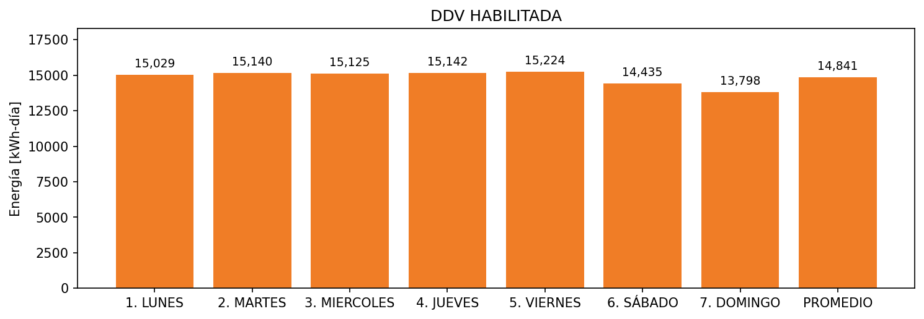

|  |  |  |  |  |  |  |  |  |  |
| --- | --- | --- | --- | --- | --- | --- | --- | --- | --- |
| **FRONTERA** | **COD SIC** | **FRT DDV** | **TIPO DDV** | **PROMEDIO** | **PRÓXIMA ACTUALIZACIÓN** | **MARGEN DE ERROR** | **ÚLTIMA PRUEBA DDV** | **DÍAS PARTICIPACIÓN** | **FECHA REFERENCIA PRÓXIMA PRUEBA DDV** |
| CLINICA PORTO AZUL S.A. - CPA | Frt20561 | Frt32406 | LBC | 14,841 | 2022-03-04 | 2,18 | 2021-10-14 | 10.0 | 2022-03-04 |